# Ohm’s Law and Resistance

**Pre-lab questions**

1. What is the goal of this experiment? What physics and general science concepts does this activity demonstrate to the student?
2. What is a statement of Ohm’s law?
3. If the voltage across a conductor is doubled, how does the electric current change? What would happen if the polarity of the voltage is reversed? How does the resistance change?

The goal of this experiment is to investigate the relationship between current *I* and voltage *V* for a conductor, usually a metal. Additionally, it examines how the resistance of a conductor to the flow of electric current depends on the length and cross-sectional area of the conductor.

**Introduction**

If a potential difference *V*is applied across a conductor, there is a flow of electric charges called **electric current**, *I***.** Currentis defined as the rate of flow of charges, i.e. the amount of electric charge passing through a cross-section of a conductor per unit time: *I =* Δ*Q /*Δ*t*. The direction of current flow is defined as the flow of **positive** charges, although the actual flow of charges in most conductors consists of electrons moving in the opposite direction. Electrical resistance in a conductor arises from collisions of electrons moving in an electric field with the vibrating lattice of positive ions.

The overall motion of the electric charges is due to the electric field they experience inside the conductor. (Unlike the case of static electric charges in a conductor where no internal electric field is possible, the dynamic flow of electric charges implies the existence of a non-zero, internal electric field.) The average electric field magnitude *E* through the interior of a conductor of length *l* relates to the applied electric potential difference *V* as *E* = *V*/*l*.

**Ohm’s Law** states that the current flow through a conductor is directly proportional to the applied potential difference across it, and that the resistance of the conductor is independent of this voltage: $I=V/R.$ A graph of *V* vs. *I* should result in a straight line that has a slope equal to *R*. $I=\frac{V}{R}$

The resistance of a conductor depends on its material content and its physical size. For a conductor of length*l*and cross-section area*A***,** the resistance *R* relates to the material resistivity *ρ*by: $R=ρl/A$. A graph of *R* vs. *l* should result in a straight line that has a slope equal to *ρ/A.*

The resistivity, *ρ*, is a characteristic of the material the conductor is made of. Each material has its own internal structure and resists the flow of current differently. If a conductor is subject to an electric field **E**, the electric current density (current per unit cross-section area) **j** inside the conductor is: $j=E/ρ$.

**Equipment**

Resistance Apparatus, PASCO 850 power supply, voltage sensor, patch cords, micrometer.

**Experiment**

The resistivity of different metals is determined by finding the resistance of wires of a known diameter as a function of their length. It is also shown that the resistance of a wire of fixed length is inversely proportional to its cross-sectional area.

**Setup**

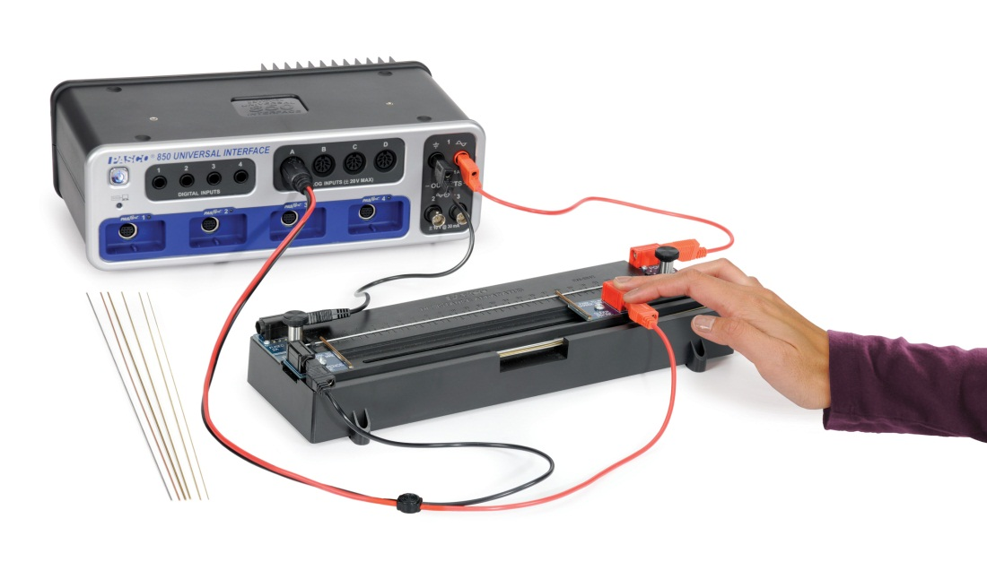

Figure 1: Setup

1. Make the connections as shown in Figure 1. In PASCO Capstone Hardware Setup, click on Signal Generator #1 and select the Output Voltage Current Sensor. Set the sample rate of all the sensors to 100 Hz.
2. Open the Hardware Setup and click on the properties gear icon for the Voltage Sensor (UI-5100). Set the gain to 1000.
3. Select four brass wires of different diameter and measure* their diameters. Also select one each of the other wires (Nichrome, Steel, Aluminum, and Copper) and measure the diameters of each. Brass is yellow in color. The Aluminum, Steel, and Nichrome are all grey in color. The Aluminum is a lighter grey, and Nichrome is a uniform dark grey. The Steel is also dark grey, but not as uniform in color. Best way to tell is using a magnet. Of the five metals, only steel will be attracted to a magnet. Change the values in the Brass Wire table under the Data tab to match your values for Brass. Change the values in the Different Metals table under the Resistivity tab to match your values for the five different metals.

*If you do not have a micrometer (or good digital calipers), use these values of diameter:  
0.127 cm  
0.101 cm (use this for the non-brass wires as well)  
0.082 cm  
0.051 cm

1. On the Resistivity Apparatus, move the Reference Probe and the Slider Probe to the Park position. The probes should be as far left and right respectively as possible so the probe lifts up to allow installation of the sample wire. They will click into position.
2. Turn the two black handles counterclockwise to open the clamps to allow the sample wire to slide into position.
3. Install the copper wire in the apparatus. Slide from left or right using the white line-up hash marks. Figure 2 shows the right hand side as the wire slides in. Note that on the right hand side, the wire is on the far side of the silver clamp (with black handle), but on the left hand side the wire will be on the near side of the clamp as shown in Figure 3. This prevents the wire from bowing as you tighten the clamps.
4. Tighten the clamps by turning the black handles clockwise.
5. Position the reference probe at the 0 cm mark and the slider probe at the 5 cm mark.

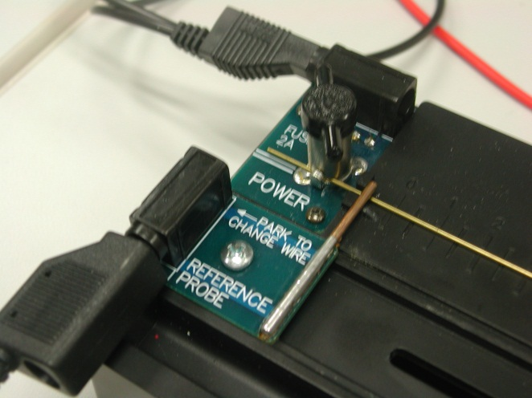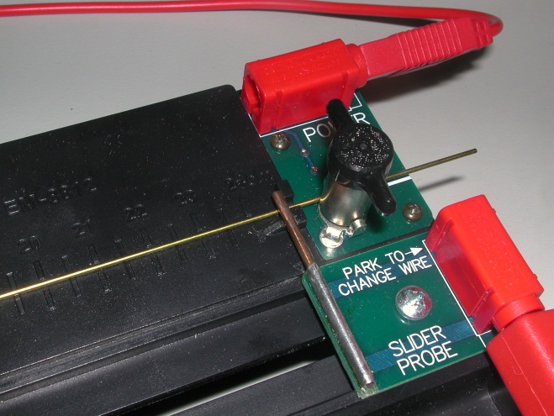

Figure 3: Left hand clamp

Figure 2: Right hand clamp

1. In PASCO Capstone or the software of your choice, create a table with a user-entered data set called “Wire Length” with units of cm. Then, in the second column, create a user-entered data set called “Resistance” with units of mΩ.

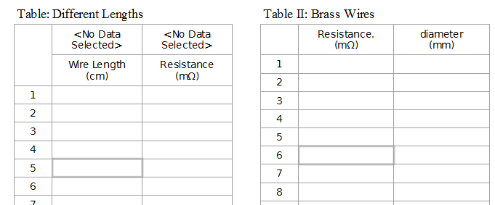

1. Create another table with a user-entered data set called “Resistance.” (*note the period*) with units of mΩ. Then, in the second column, create a user-entered data set called “diameter” with units of mm.
2. Create a third table with five columns:

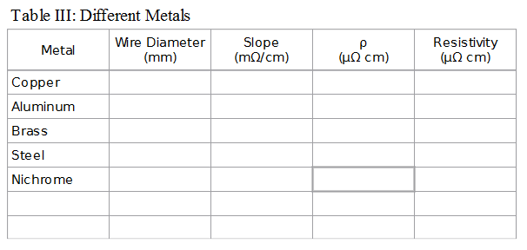

The first column has a user-entered data set called “Metal”. The second column has a user-entered set called “Wire Diameter” with units of mm. The third column has a user-entered set called “Slope” with units of mΩ/cm. The fourth column has the calculation ρ as defined in the next step. The fifth column has a user-entered set called “Resistivity” with units of mΩ-cm. Enter the following manufacturer’s values for the Resistivity: Copper - 1.8 ± 0.1; Aluminum - 4.9 ± 0.1; Brass - 7.0 ± 0.5; Steel - 79 ± 1; Nichrome - 105 ± 5.

1. Open the calculator and create the following calculations:

‎V‎ = 1000*avg([Voltage, Ch A‎]) Units of mV

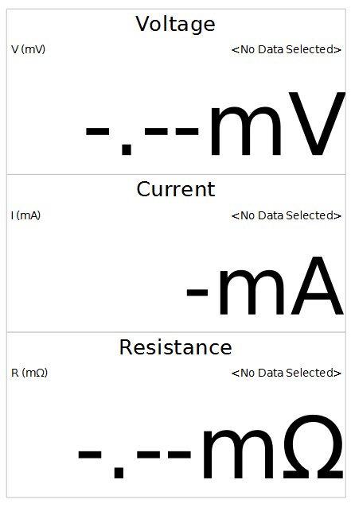‎I‎ = 1000*avg([Output Current, Ch O1]) Units of mA

‎R‎ = 1000*[V‎]/[I‎] Units of mΩ

‎Area ‎= π*([diameter‎]/2)^2 Units of mm2

‎ρ‎ = (π*([Wire Diameter‎]/2)^2)*[Slope(mΩ/cm]*10 Units of μΩ-cm

1. Create three digits displays and choose the calculations: V(mV), I(mA), and R(mΩ).
2. Create a graph of Resistance vs. Length.

**Procedure**

1. Click open the Signal Generator (left side of screen). 850 Output 1 should be set for a DC voltage of 2.0 V. Click the On button to turn the Signal Generator on.
2. Move the Slider Probe on the Resistance Apparatus so the contact is at 5.0 cm.
3. *Read the rest of this page*, then click open the Data tab. The program will ask if you wish to turn off the Signal Generator, click Leave On.
4. Click RECORD at the bottom left of the screen. Wait a few seconds until the numbers stop changing and then click STOP.
5. The resistance in the lower box is calculated from *R* = *V*/*I* where the *V* and *I* values are averages that show in the upper two boxes. In the first row of the Table I, enter the Resistance and then the Wire Length (5.0 cm).
6. Repeat steps 4 & 5 for Slider Probe positions of 10.0 cm, 15.0 cm, 20.0 cm, & 24.0 cm.
7. The Data summary should show five runs. Double click on the last run (probably Run #5) and re-label it Copper. Delete all the other runs using the white triangle by the Delete Last Run icon at the bottom of the page.
8. Create a new table with a user-entered data set called “Wire Length” with units of cm. Then, in the second column, create a user-entered data set called “Resistance” with units of mΩ.
9. Replace the Copper wire with the Aluminum wire. The Aluminum wire is lighter in color and weighs less. Repeat steps 4 thru 8 except label the last run Aluminum. Delete all the other runs except for Copper.
10. Repeat for the Steel and Nichrome wires except do step 2 again and change the Gain to 10x.
11. Repeat for the 1.0 mm (second largest) brass wire except do step 2 and change the Gain to 100x. When you do the 24 cm run, enter in the Table I as before, but also enter it in the Table II in the 1 mm row.
12. Repeat for the other three brass wires, except only do the 24 cm position and enter the data in the Table II. Label the runs Brass 127, Brass 82, Brass 51.

**Analysis**

1. The graph shows the resistances you measured versus the length of wire you used. From the graph toolbar, click the Run Select black triangle and select the Copper run.
2. Click the Scale-to-fit icon at the top left of the toolbar.
3. Click the black triangle by the Curve Fit icon on the toolbar and select Linear. Right click in the Linear box and click on Show Uncertainty if it is not already showing.
4. Record the slope, *m*, of the *R* versus *L* graph in the Slope column of the Table III. Note that in most cases the uncertainty in the slope is less than 1%.
5. Repeat for each of the different metals.

**Conclusions**

1. How well does the data fit straight lines? What does this show?
2. Click open the Calculator at the left of the page and verify that line 5 calculating ρ multiplies the slope *m* of the graph by the cross-section area *A* of the wire. (*The factor of 10 arises from converting from mm2(mΩ)/cm to μΩ-cm.*) Click the Calculator closed.
3. The value calculated for ρ is given in column 3. Except for Nichrome, the major source of uncertainty is the measurement of the diameter. If you measured this with a micrometer or digital calipers that read to 0.01 mm, the uncertainty in ρ is about 1%. Nichrome may have had a larger uncertainty in Slope due to spread in the data.
4. Column 4, labeled Resistivity, contains the manufacturer’s values. The uncertainty arises because the metal wires are actually alloys and the actual resistivity depends on the exact composition.
5. Discuss how well your data agree with the given values.

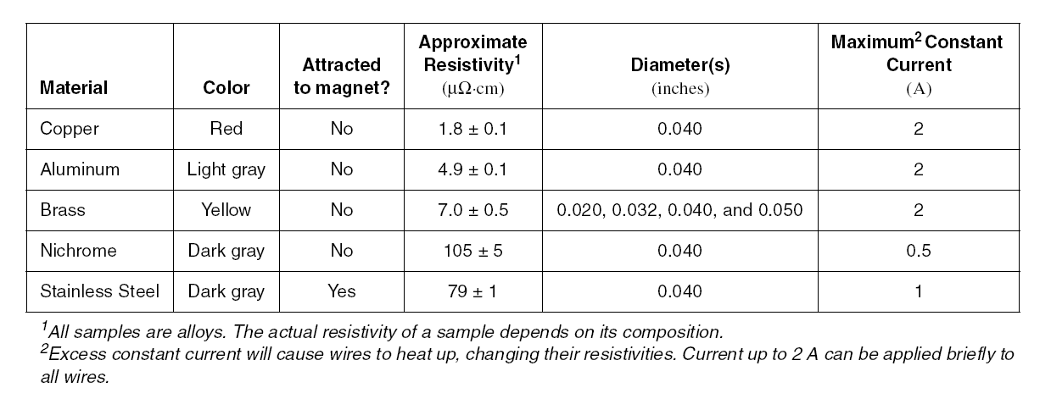

**Area Dependence**

1. Create a graph of the resistances you measured (Resistance.) versus the cross-sectional area for the four brass wires.
2. On the Area axis, click on the measurement and select the quick-calc x-1.
3. Click on the Curve Fit black triangle and turn on Linear.
4. How well does your data fit a straight line? What does this show about the resistance dependence on cross-sectional area? What is the physical meaning of the slope?